**WEB DATABASE LAB**

## “LEAVE MANAGEMENT SYSTEM” PROJECT FLOW

|  |  |
| --- | --- |
| **Front Interface of Project** | |
| **G:\Bijan Pendrive data\EW\My Web Database\3 4 5 7 PHP Basic\Week 7_MySql\Demo of Leave Management System\Image of LMS\1.Login.png** | **G:\Bijan Pendrive data\EW\My Web Database\3 4 5 7 PHP Basic\Week 7_MySql\Demo of Leave Management System\Image of LMS\2.Admin Login.png** |
| **“Login” Page** | **“Admin Login” Page** |
| **G:\Bijan Pendrive data\EW\My Web Database\3 4 5 7 PHP Basic\Week 7_MySql\Demo of Leave Management System\Image of LMS\3.Employee Login.png** | **G:\Bijan Pendrive data\EW\My Web Database\3 4 5 7 PHP Basic\Week 7_MySql\Demo of Leave Management System\Image of LMS\4. Employee Register.png** |
| **“Employee Login” Page** | **“New Employee Register” Page** |
| **G:\Bijan Pendrive data\EW\My Web Database\3 4 5 7 PHP Basic\Week 7_MySql\Demo of Leave Management System\Image of LMS\5. Employee Application Form.png** | **G:\Bijan Pendrive data\EW\My Web Database\3 4 5 7 PHP Basic\Week 7_MySql\Demo of Leave Management System\Image of LMS\6.Admin Check Application.png** |
| After Successfuly Login by Employee get **“Employee Application Page”** | After Successfuly Login by Admin get **“Admin Check Application Page”** by which Admin Can Accept or Reject Applications |
| G:\Bijan Pendrive data\EW\My Web Database\3 4 5 7 PHP Basic\Week 7_MySql\Demo of Leave Management System\Image of LMS\7. Employee Status Check.png | G:\Bijan Pendrive data\EW\My Web Database\3 4 5 7 PHP Basic\Week 7_MySql\Demo of Leave Management System\Image of LMS\8.Admin Still Now Not Process Applications.png |
| Employee can check Application Status by clicking “Status Check” button after Login | If Applications are not process by admin show this message if click in “Status Check” button |

## Database

**Database Name:** LMS

**Tables:**

* **Admin\_Login Table**

**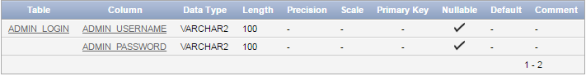**

Create table Admin\_Login

(

Admin\_Username varchar(100),

Admin\_Password varchar(100)

);

insert into Admin\_Login values('a', 'a');

* **Employee\_Database Table**

**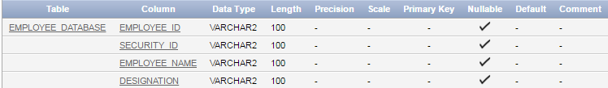**

Create table Employee\_Database

(

Employee\_Id varchar(100),

Security\_Id varchar(100),

Employee\_Namevarchar(100),

Designation varchar(100)

);

insert into Employee\_Database values('11','11','ewu','developer');

* **Employee\_Application Table**

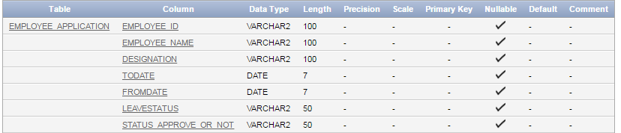

Create table Employee\_Application

(

Employee\_Id varchar(100),

Employee\_Name varchar(100),

Designation varchar(100),

ToDate date,

FromDate date,

LeaveStatus varchar(50),

Status\_Approve\_Or\_Not varchar(50)

);

## WHAT & HOW TO SUBMIT

You need to send me email [**bijon\_sust@yahoo.com**](mailto:bijon_sust@yahoo.com). Email subject must be WebDB\_LT\_ID